'Severe' coral bleaching is damaging huge swaths of the Great Barrier Reef, scientists say
10:02 AM Wednesday Mar 30, 2016
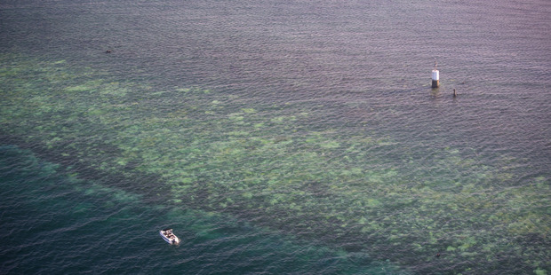Bleaching of the Great Barrier Reef observed by aerial survey.
Photo: Terry Hughes, ARC Centre of Excellence for Coral Reef Studies
Scientists have declared that key portions of the Great Barrier Reef - over a thousand miles long and the "largest living structure on the planet," according to Australia's Great Barrier Reef Marine Park Authority - are now seeing the worst coral bleaching in recorded history.
"We're seeing very severe bleaching in the northern part of the reef," said Professor Terry Hughes of James Cook University, where he heads the Australian Research Council (ARC) Centre of Excellence for Coral Reef Studies. "And I think that just highlights how precarious the situation has become, whereby severe El Niño events, which happen every few years, are enough to trigger a bleaching event. And it wasn't always like that."
Hughes spoke after undertaking an aerial survey of 520 reefs north of Cairns, Australia, and encompassing the northern part of the reef.
"We found only 4 reefs out of 520 that weren't bleached to some extent, and more than 95 percent of the reefs were in the top 2 most severe bleaching categories," Hughes said. A prior bleaching event in 2002 led to only 18 percent of reefs falling into these two categories, Hughes said, meaning that, at present, the "northern barrier reef is much more severely bleached than ever before," he said.
A news release from Australia's National Coral Bleaching Taskforce describing the result did not mince words, saying that "the most pristine section of the Great Barrier Reef is currently experiencing the worst, mass bleaching event in its history."
The news would appear to worsen an already bad assessment on March 20 by the Great Barrier Reef Marine Park Authority, which noted up to 50 percent reef mortality off Cape York, in the far northern reef, but still said that many more southern parts of the reef were faring at least moderately well.
The Great Barrier Reef hugs the north-eastern coast of Australia, over an ocean region that is roughly three quarters the size of California. So it's no surprise that not all of it is being affected equally. But the northern reefs are viewed as the most "pristine," in Hughes's words.
The Great Barrier Reef is a World Heritage Site, the home to 400 species of coral and 1,500 fish species. On listing the site, UNESCO commented that "if only one coral reef site in the world were to be chosen for the World Heritage List, the Great Barrier Reef is the site to be chosen."
Bleaching is a phenomenon that occurs when corals, stressed by warm ocean temperatures, banish from their bodies the algae that live with them and provide them with energy through photosynthesis. Without the algae, the corals not only turn white but can die if the stresses continue long enough.
Bleaching is not the same as mortality, though, and right now, just how many corals have died or will die remains unclear. But Hughes said divers in the water are seeking to determine just this, and already, he feels the bleaching event will have a "long-term damaging impact on the northern reefs."
Global warming has long been viewed as a major threat to corals because it raises sea temperatures and because the pH of the ocean shifts toward a more acidic level as carbon uptake increases, and ocean acidification can interfere with the skeleton growth of corals.
A 2007 study found that as climate change advances during the 21st century, warming and acidification will lead to "corals becoming increasingly rare on reef systems."
The current bleaching event is most immediately related to the strong El Niño of 2015-2016, although Hughes suggests that it is only the latest few El Niños, presumably enhanced by climate change, that have sparked mass coral bleaching. Indeed, the developments in the Southern Hemisphere are just the latest in a global bleaching event that is now the longest running of its kind on record, according to Mark Eakin, a corals expert with the National Oceanic and Atmospheric Administration.
"This is a lot broader than just what's going on in the Great Barrier Reef. It's literally happening across half of the Southern Hemisphere at this point," Eakin said.
The current bleaching event goes back to June 2014, when bleaching appeared in the central and eastern Pacific. It carried on in various locations, including Hawaii and the Caribbean, in 2015 and is continuing this year.
Eakin and NOAA declared it a global bleaching event late last year. Eakin said that by the end of 2015, close to a third of corals worldwide had experienced temperatures hot enough to cause bleaching.
"This is not like any global bleaching event we've seen in the past," Eakin said. "In the past, these events have been a one-year event. What happened in '98, happened in '98. It was all within the scope of less than 12 months."
Scientists have observed only three global coral bleaching events - in 1998, 2010 and now. All three events involved El Niño years, although the current event began well before El Niño was officially declared.
1998 was the most severe - so far - ultimately causing the loss of about 16 percent of the world's coral reefs at that time, according to Eakin. He said we won't know the full impact of the current bleaching event until actual reef surveys can be conducted across the world.
Coral reefs are at the heart of diverse subsea ecosystems that support large numbers of fish and other marine species and thus benefit humans in multiple ways. They support fisheries and tourism. A 2008 report from Conservation International and several other groups noted that the "net benefit" of coral reefs globally had been estimated at $29.8 billion per year, including benefits from tourism, fisheries, coastal protection and the preservation of biodiversity.
That's why the ongoing coral bleaching event is so alarming - and, according to Eakin, as the Southern Hemisphere summer fades, bleaching could shift back to the Northern Hemisphere later this year. "We're just in the opening parts of Act 2 at this point," he said.
Washington Post

