Increasing atmospheric CO2 concentrations lower oceanic pH and carbonate ion concentrations, thereby decreasing the saturation state with respect to calcium carbonate (Feely et al., 2004). The main driver of these changes is the direct geochemical effect due to the addition of anthropogenic CO2 to the surface ocean (see Box 7.3). Surface ocean pH today is already 0.1 unit lower than pre-industrial values (Section 5.4.2.3). In the multi-model median shown in Figure 10.23, pH is projected to decrease by another 0.3 to 0.4 units under the IS92a scenario by 2100. This translates into a 100 to 150% increase in the concentration of H+ ions (Orr et al., 2005). Simultaneously, carbonate ion concentrations will decrease. When water is undersaturated with respect to calcium carbonate, marine organisms can no longer form calcium carbonate shells (Raven et al., 2005).

Figure 10.23
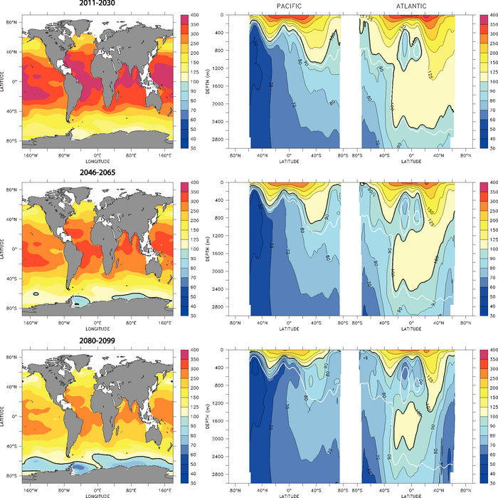
Figure 10.23. Multi-model median for projected levels of saturation (%) with respect to aragonite, a meta-stable form of calcium carbonate, over the 21st century from the Ocean Carbon-Cycle Model Intercomparison Project (OCMIP-2) models (adapted from Orr et al., 2005). Calcium carbonate dissolves at levels below 100%. Surface maps (left) and combined Pacific/Atlantic zonal mean sections (right) are given for scenario IS92a as averages over three time periods: 2011 to 2030 (top), 2045 to 2065 (middle) and 2080 to 2099 (bottom). Atmospheric CO2 concentrations for these three periods average 440, 570 and 730 ppm, respectively. Latitude-depth sections start in the North Pacific (at the left border), extend to the Southern Ocean Pacific section and return through the Southern Ocean Atlantic section to the North Atlantic (right border). At 100%, waters are saturated (solid black line - the aragonite saturation horizon); values larger than 100% indicate super-saturation; values lower than 100% indicate undersaturation. The observation-based (Global Ocean Data Analysis Project; GLODAP) 1994 saturation horizon (solid white line) is also shown to illustrate the projected changes in the saturation horizon compared to the present.

Figure 10.23. Multi-model median for projected levels of saturation (%) with respect to aragonite, a meta-stable form of calcium carbonate, over the 21st century from the Ocean Carbon-Cycle Model Intercomparison Project (OCMIP-2) models (adapted from Orr et al., 2005). Calcium carbonate dissolves at levels below 100%. Surface maps (left) and combined Pacific/Atlantic zonal mean sections (right) are given for scenario IS92a as averages over three time periods: 2011 to 2030 (top), 2045 to 2065 (middle) and 2080 to 2099 (bottom). Atmospheric CO2 concentrations for these three periods average 440, 570 and 730 ppm, respectively. Latitude-depth sections start in the North Pacific (at the left border), extend to the Southern Ocean Pacific section and return through the Southern Ocean Atlantic section to the North Atlantic (right border). At 100%, waters are saturated (solid black line - the aragonite saturation horizon); values larger than 100% indicate super-saturation; values lower than 100% indicate undersaturation. The observation-based (Global Ocean Data Analysis Project; GLODAP) 1994 saturation horizon (solid white line) is also shown to illustrate the projected changes in the saturation horizon compared to the present.

Under scenario IS92a, the multi-model projection shows large decreases in pH and carbonate ion concentrations throughout the world oceans (Orr et al., 2005; Figures 10.23 and 10.24). The decrease in surface carbonate ion concentrations is found to be largest at low and mid-latitudes, although undersaturation is projected to occur at high southern latitudes first (Figure 10.24). The present-day surface saturation state is strongly influenced by temperature and is lowest at high latitudes, with minima in the Southern Ocean. The model simulations project that undersaturation will be reached in a few decades. Therefore, conditions detrimental to high-latitude ecosystems could develop within decades, not centuries as suggested previously (Orr et al., 2005).

Figure 10.24
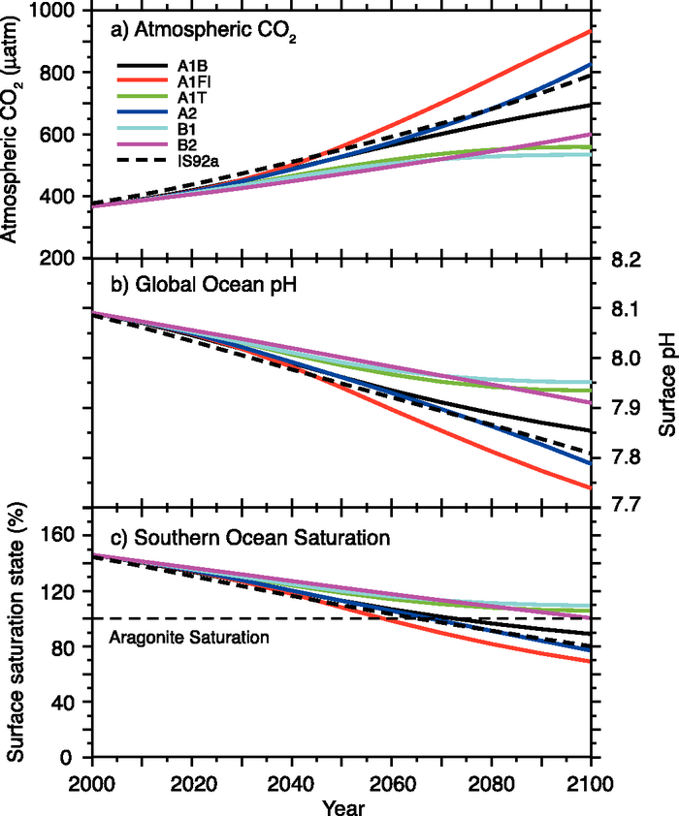

Figure 10.24. Changes in global average surface pH and saturation state with respect to aragonite in the Southern Ocean under various SRES scenarios. Time series of (a) atmospheric CO2 for the six illustrative SRES scenarios, (b) projected global average surface pH and (c) projected average saturation state in the Southern Ocean from the BERN2.5D EMIC (Plattner et al., 2001). The results for the SRES scenarios A1T and A2 are similar to those for the non-SRES scenarios S650 and IS92a, respectively. Modified from Orr et al. (2005).

While the projected changes are largest at the ocean surface, the penetration of anthropogenic CO2 into the ocean interior will alter the chemical composition over the 21st century down to several thousand metres, albeit with substantial regional differences (Figure 10.23). The total volume of water in the ocean that is undersaturated with regard to calcite (not shown) or aragonite, a meta-stable form of calcium carbonate, increases substantially as atmospheric CO2 concentrations continue to rise (Figure 10.23). In the multi-model projections, the aragonite saturation horizon (i.e., the 100% line separating over- and undersaturated regions) reaches the surface in the Southern Ocean by about 2050 and substantially shoals by 2100 in the South Pacific (by >1,000 m) and throughout the Atlantic (between 800 m and 2,200 m).

Ocean acidification could thus conceivably lead to undersaturation and dissolution of calcium carbonate in parts of the surface ocean during the 21st century, depending on the evolution of atmospheric CO2 (Orr et al., 2005). Southern Ocean surface water is projected to become undersaturated with respect to aragonite at a CO2 concentration of approximately 600 ppm. This concentration threshold is largely independent of emission scenarios.

Uncertainty in these projections due to potential future climate change effects on the ocean carbon cycle (mainly through changes in temperature, ocean stratification and marine biological production and re-mineralization; see Box 7.3) are small compared to the direct effect of rising atmospheric CO2 from anthropogenic emissions. Orr et al. (2005) estimate that 21st century climate change could possibly counteract less than 10% of the projected direct geochemical changes. By far the largest uncertainty in the future evolution of these ocean interior changes is thus associated with the future pathway of atmospheric CO2.
AR4 Repo

