Nervous Communication
- The nervous system has 3 functions:

- The nervous system contains 3 parts:

- Neurons
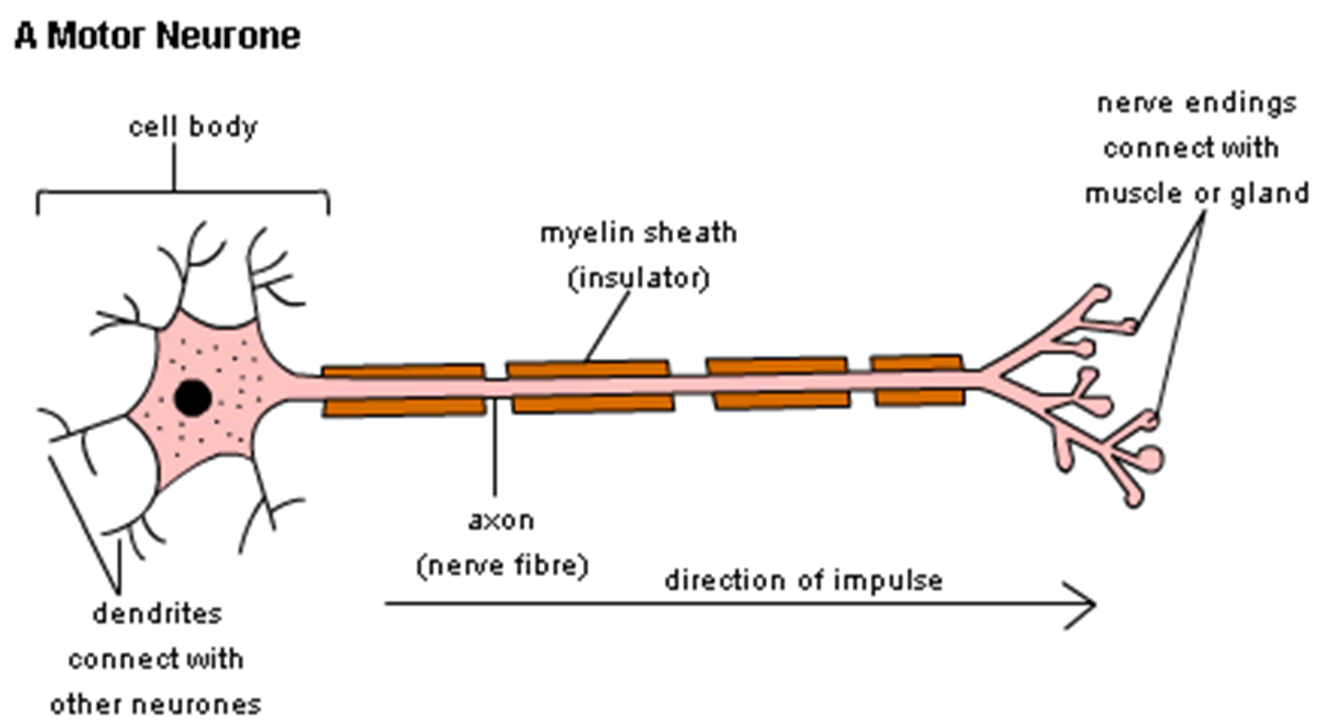
- In the spinal cord, there are 3 general types of neuron:

- The CNS is protected by 3 layers:

- Speeding up Transmission of Nerve Impulses:

- Properties of the impulse:

- Synapses:

- The Autonomic Nervous System:

- Effector:

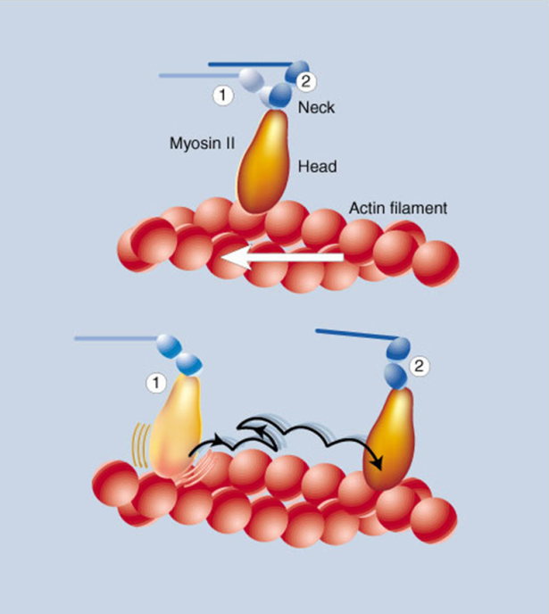

- The machines in your muscles:

- Smooth muscle:

